

**A 12**

**Sreenidhi Institute of Science & Technology**

(An Autonomous Institution)

**Code No: 121EE43**

**B. TECH. I – Year II – Semester Examinations, July, 2014 (Regular)**

**NETWORK ANALYSIS (ECM)**

**Time: 3 Hours Max. Marks: 70**

**Note: No additional answer sheets will be provided.**

**Part-A**

**Max.Marks:20**

**Answer all QUESTIONS.**

1. State Kirchoff’s Voltage and Current Laws.
2. Define (i) Graph (ii) Tree.
3. Define Form factor.
4. State Superposition theorem.
5. Find the transfer impedance of the two-port network shown.

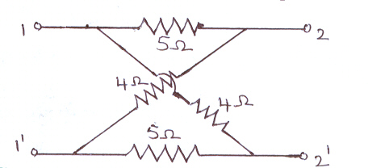

1. Define Time constant.
2. Three equal resistances of 3Ω are connected in star. What is the resistance in one of the arms in an equivalent delta circuit?
3. Define self and mutual inductances.
4. Define Low pass and high pass filters.
5. What is meant by Duality of a network?

**Part – B**

**Max. Marks: 50**

**ANSWER ANY FIVE QUESTIONS. EACH QUESTION CARRIES 10 MARKS.**

1.(a) Using Kirchoff’s laws find the currents in each resistor of the network shown. 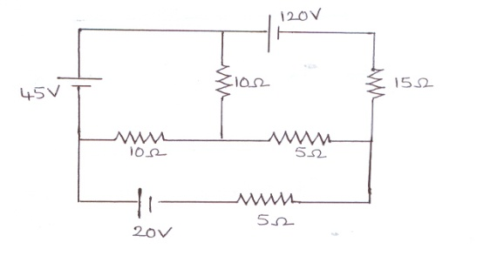

(b) Using mesh analysis, find the current flowing through 6Ω resistance in the circuit shown. 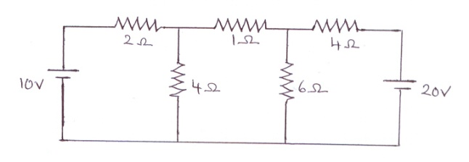

2.(a) Explain about the basic cut-set matrix for planar networks.

(b) Obtain the fundamental cut-set matrix Qf for the network graph shown. 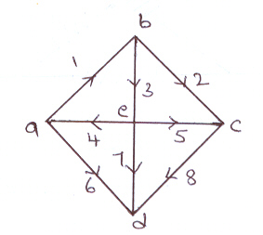

3. (a) Explain the analysis of RC series circuit with sinusoidal excitation.

(b) An iron ring of cross sectional area 800 mm2 and of mean radius 170 mm has two windings connected in series, one of 500 turns and the other 700 turns. If the relative permeability of iron is 1200, find the self inductance of each coil and the mutual inductance assuming that there is no leakage.

4. (a) Using Thevenin’s theorem, find the current in 6Ω resistor.

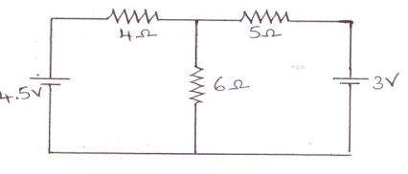

(b) State and prove Maximum power transfer theorem.

5. (a) Find the transmission (ABCD) parameters for the circuit shown.

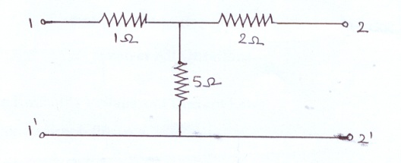

(b) Explain about the cascaded configuration of two-port networks.

6.(a) Explain the transient response of series RL circuit with DC excitation.

(b) In the circuit shown, find the solution for the current when switch S is closed at t = 0. 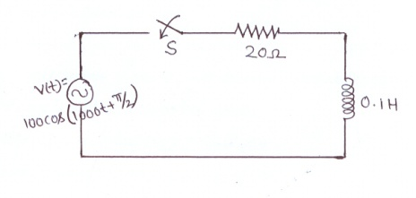

7. (a) With an example, explain super mesh concept.

(b) Explain about the resonance in parallel R-L-C circuit.

8. (a) State and explain Norton’s theorem.

(b) Explain about the condition for reciprocity and symmetry of two-port network.

**-- 00 -- 00 --**